CRITERIA FOR 2 MINUTE VIDEO INTERVIEW

You have 2 minutes to tell us why you think you are a good candidate for the PASE program.

Video set up
- Record on your laptop or a phone
- Make sure you find a quiet place to record your interview
- Ensure your face is clearly visible
- The video should only be of you, not family members or friends or pets
- Before sending your video ensure you can be clearly heard and the lighting is good
- It’s okay to write out your responses to the questions beforehand to help you know what to say

Here are some questions to guide your video. Remember that we have read your application letter, try to come up with new-creative ideas. It is your chance to tell us more about yourself.

- Briefly introduce yourself in your happy place and why this place is important for you.

- In PASE, you will continually work in teams.

- Share an experience you’ve had as part of a team working well together.
II. Share an experience you’ve had as part of a team not working well together.

- There are also often projects that you have to work on individually or as a team. How do you usually organize your time?

- Describe yourself as a learner. Is academic work easy or harder for you? Do you require extra support? This answer won’t have a negative impact on the selection. It will simply help me be a better teacher…

- How do you see yourself in a place where you LIVE in French 100% of the time?

How to share your video when it's ready:
Open your account through RapidIdentity, open G suite, upload your video to your “Drive” by choosing “File upload”. It will take some time. Then share with me at karine.belanger@yesnet.yk.ca

Here are the steps specifically:
- Choose G Suite for Education
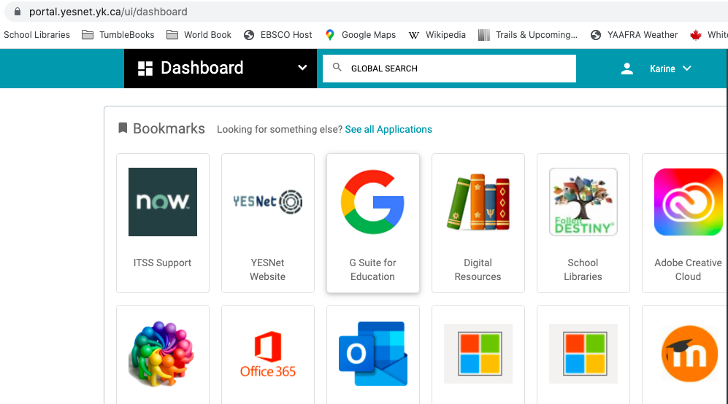
- On your Drive on the left at the top of the page, click on “New” and choose “File upload”
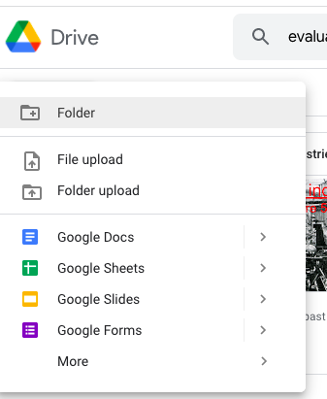

- When your document is uploaded, look at the top right, click on the 3 vertical dots and choose “share”

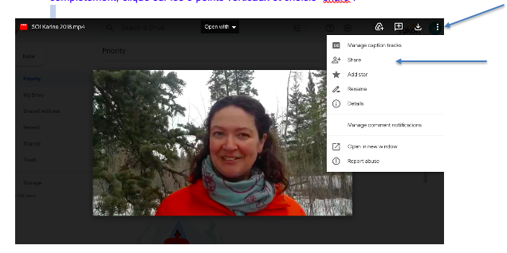

- Then you choose my name karine.belanger@yesnet.yk.ca

- Also send me a message that says you shared your video, and I will confirm I have received your video.

You can also send it to my by email at karine.belanger@yesnet.yk.ca, or stop by the school to do an Airdrop or bring it on a USB stick.

Bonne chance

