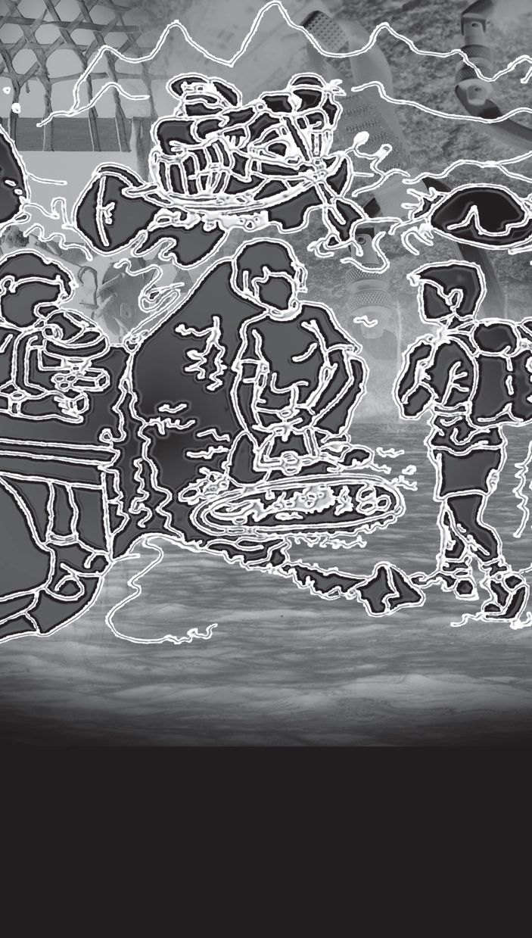  Plein Air et Sciences  Expérientielles  « La Nature est le meilleur enseignant »  Understanding our environment through activity and study | APPLICATION FOR PASE 9  Deadline is Monday, January 29th, 2024  You must provide  - Letter in French including information about  - your interests and activities  - your strengths, your areas of improvement  - why you would like to be in PASE  - why you think you would be a good choice for the program  along with information page, send letter to  applications-WSC@yukon.ca  - 2 minutes Video in French – expectations are  posted on PASE webpage with instructions on how  to send it directly to Karine Bélanger  Be aware that we will also be contacting teachers at your home school for their recommendations – don’t ask them.  More information available on  pase9.weebly.com  and  www.woodstreetcentre.yukonschools.ca/  Information session available on Zoom on:  Monday January 15th between 7:00 – 7:30 pm  Zoom link will be available on PASE webpage  Contact Karine Bélanger at karine.belanger@yesnet.yk.ca if you have any specific questions | Student Information  PASE 9 is a co-educational program open to all Grade 9 students. Although prior wilderness experience is not a criterion for selection into this program, students should be able to meet the physical demands of the program in remote settings. All outdoor activities and extended field trips are selected with the safety of the students in mind and are appropriate for Grade 9 students who have had little or no prior experience in the outdoors. A portion of class time will be spent preparing students for the extended wilderness trips. Class size is 16.  Student Expectations  Class size is limited to 16 students and consideration will be given to students who are trustworthy, conscientious and respectful of others.  - Previous marks are not a criterion for selection  - Students selecting this program should be committed to participating in the various outdoor and science field trips.  - Regular attendance is therefore essential  - You must be committed to speaking French 100% of the time while in class and on trips  Program Costs  The cost of the program is $350, which will cover costs associated with wilderness trips. Students are not expected to buy a lot of outdoor equipment. Those who have suitable equipment will be expected to use it. If not, Wood Street is able to provide all equipment necessary including winter sleeping bags, ski equipment, backpacking gear, stoves and pot sets, or kayaks and canoes. All students are expected to provide their own food (expect approximately the same cost as eating at home).  French Immersion Component  This program will be taught in French and will require French communication with the teacher and between the students all the time. The extended trips offer students long term immersion opportunities which increase exposure to the language.
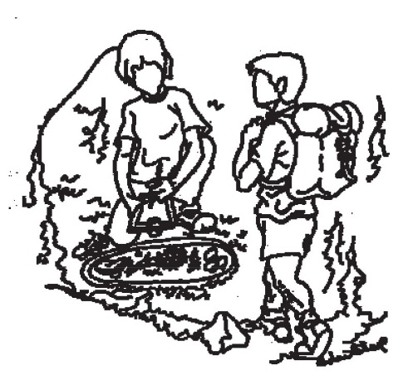  PASE 9 – Plein Air et Sciences Experientielles  General Progam Description  Plein Air et Sciences Experientielles (PASE) offers an alternate approach to learning for Grade 9 students. This integrated program of studies provides students with opportunities in a variety of exciting outdoor prusuits and enriches the regular Sciences 9 and Social Studies 9 curriculum through field study experiences.  The physical education course is complimented with a variety of outdoor actiivies focused on lifelong learning and active living. Social Studies will be delivered in the classroom, as well as, through field studies. The use of technology and fine arts medium will round out this full semester integrated program.  Goals and Objectives  To encourage and develop:  - An interest for outdoor activities, sciences and specific projects  - responsible attitudes about learning, about yourself, and about your role in society  - a heightened awareness and dedication to health and fitness  - Friendship and positive peer relationships  - Leadership, communication and observation skills  - greater knowledge and appreciation of the Yukon’s natural environment (wildlife, vegetation, rock formations) and different ecological zones  - Strong French speaking skillls as an extension of the French Immersion program | Program Overview  PASE 9 will be offered one semester per school year at Wood Street Centre. This facility provides the independence that is necessary to run a successful program. In the alternate semester students will attend regular classes at F.H. Collins Secondary.  PASE Semester Alternate Semester  Sciences Naturelles 9 English 9  Plein Air (Outdoor Education) 9 Francais 9  Education Physicalle 9 Math 9  Sciences humaines 9 Elective 9  Note: Courses may change depending on the strengths of the instructor.  Safety  The safety and well-being of the students is always the first and most important consideration when taking students into wilderness settings. Students who display inappropriate or unacceptable behaviour that puts themselves or others at risk may result in removal from the field trip at their own expense and/or removal from the program.  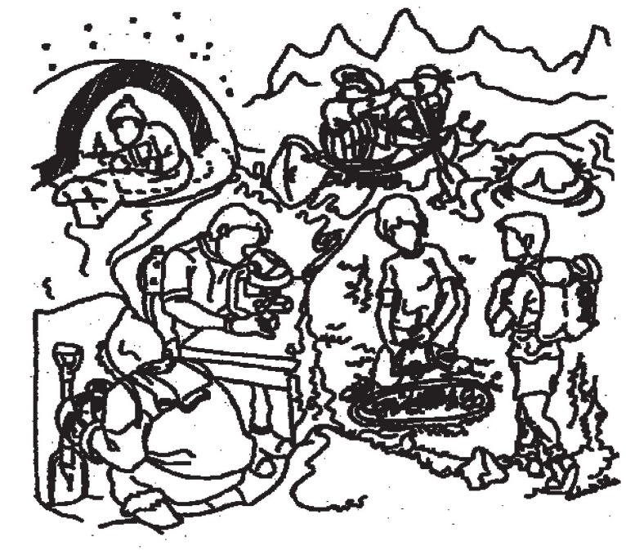 | Major Expeditions  There are five major expeditions planned for the semester between 2 and 5 days each. Dates for the trips will be made available before the start of the semester.  Program Content  Sciences naturelles 9  The Sciences naturelles 9 course is a continuation of the Science naturelles 8 program which further develops skills, practices and knowledge from the areas of Physical Science, Life Science and Earth Science. These topics include elements, the Periodic Table, compounds, chemical formulas, static electricity, current, electric circuits, cell reproduction, reproduction in living organisms and interconnection within earths spheres.  Plein air et sciences environmentales 9  This course will provide students with a wide range of exciting challenging and rewarding experiences. The course will focus on the knowledge and skills related to a variety of outdoor wilderness activities. Topics covered will include: hiking, avalanche awareness, winter camping, kayaking, climbing, wilderness ethics, field study projects (moose, snowshoe hare, forestry, water quality studies, etc.) Expeditions may include hiking, biking, overnight survival, winter camping and sea kayaking).  Education Physique 9  This course will cover traditional activities such as team, dual and individual sports. Aquatics, biking and telemark skiing will be integrated with outdoor field trips. Emphasis will be placed in participation in lifelong activities, encouraging healthy lifestyles and fitness for fun.  Sciences humaines 9  This course focuses on political, social, economic and technological revolutions in the 1750-1919 period. Topics include: Nationalism and the development of modern nation states, including Canada, demonstrate change in ideas and ideologies; Students will know how local, regional and global conflicts influenced our identity and power relations between individuals and societies; Imperialism and colonialism impacts on Indigenous populations in Canada and around the world with an emphasis on Yukon First Nation impacts.

